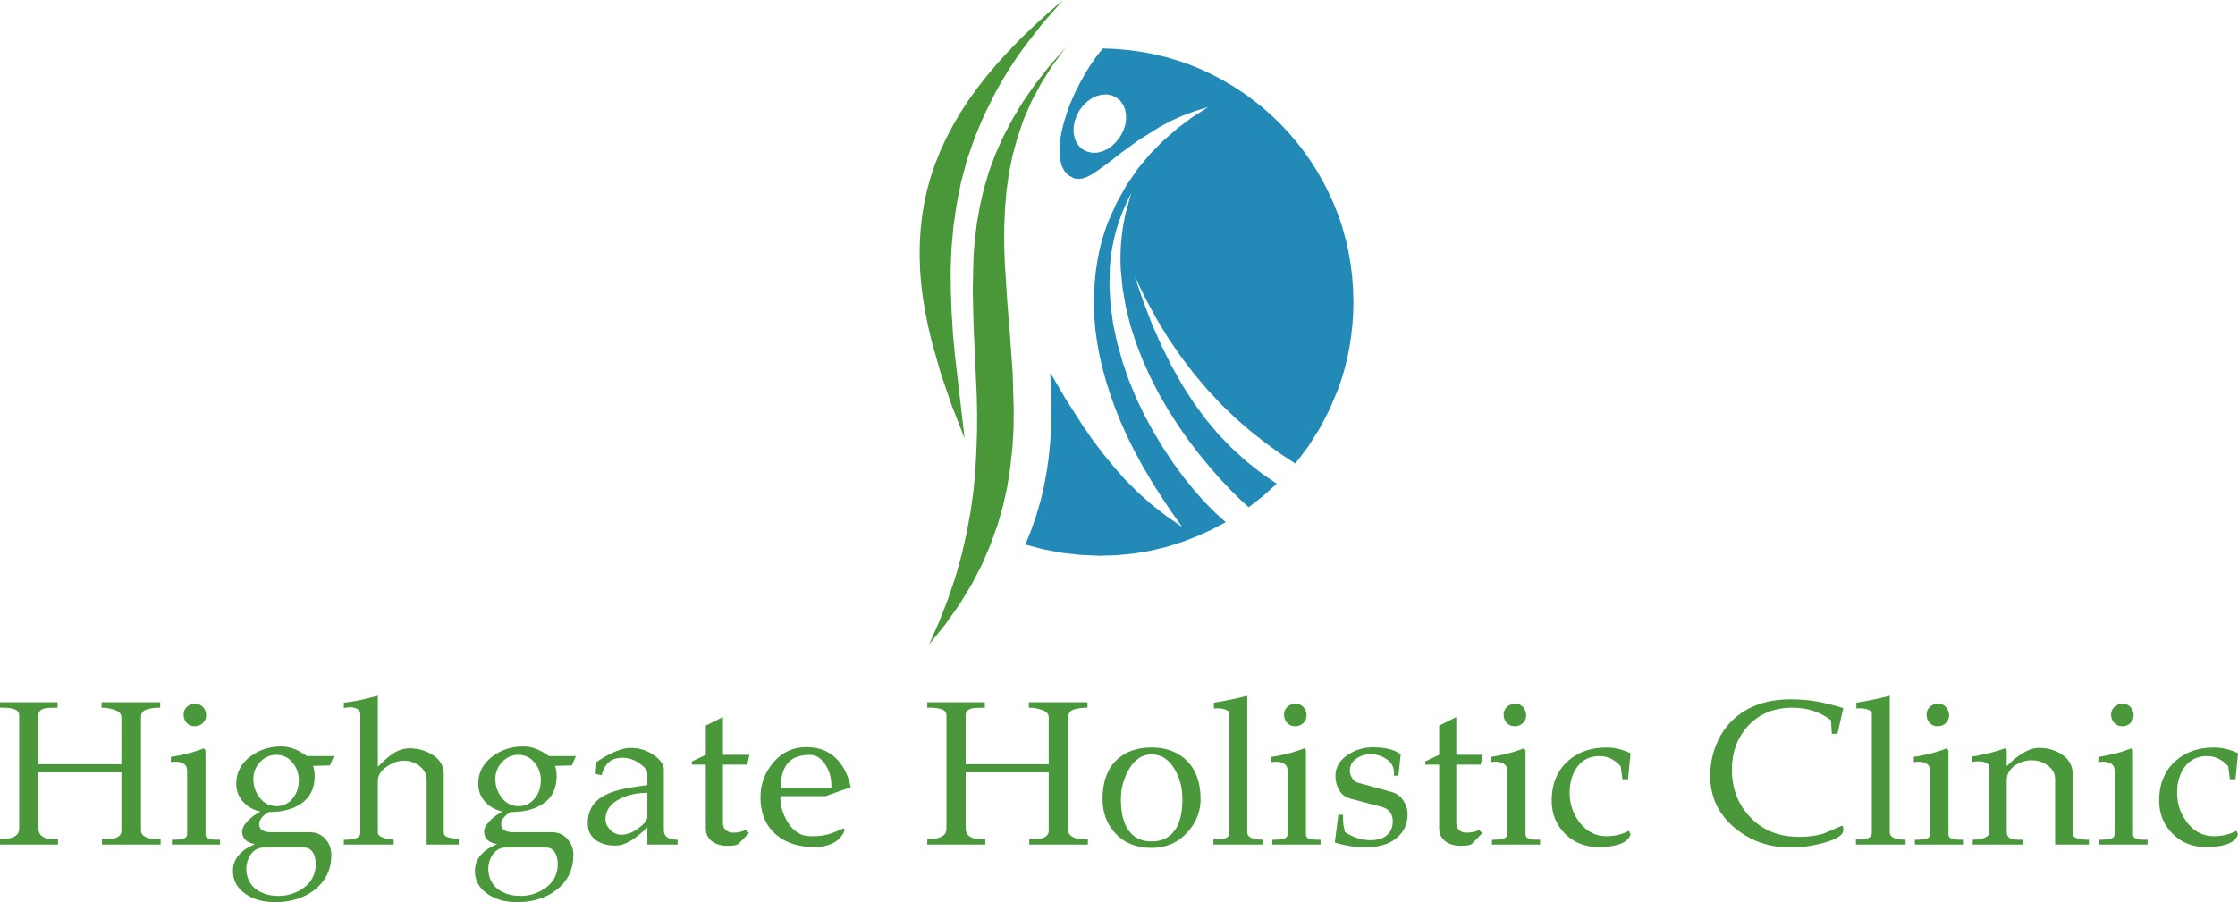

HIGHGATE HOLISTIC CLINIC
HEALTH AND SAFETY MEASURES

Dear Customers

In order to comply to the government’s new health and safety guidelines based on the COVID-19 situation, please note:

- Face masks and gloves must be worn at all times during your presence at the clinic
- Please do not use the toilets unless emergency. Plan to use the bathroom before and after visiting the clinic
- We are unable to offer water or refreshments at the time being, please bring your own
- Please use hand sanitiser before entering the premises
- Upon entering the premises please use the provided hand sanitiser at reception AND before and after entering your treatment room
- Reception area is currently closed. Please wait outside (at a 2m distance from other customers) for your therapist who will come and meet you at your given appointment time
- Door handles to be held ONLY by staff members using disposable tissues only
- We are unable to share pens or any other item during those times. Please use your own
- Please keep 2m distance between you and anybody else present AT ALL TIMES
- Only 2 people only are allowed at any time in every room (including the receptionist and your therapist)
- DO NOT enter the premises if you have any symptoms related to COVID-19. Your therapist will ask you to sign a disclaimer before offering treatment.

THANK YOU FOR YOUR KIND COOPERATION AND FOR HELPING US TO KEEP EVERYONE SAFE

